ARP Cache Poisoning Attack Lab

Task 1: ARP Cache Poisoning

Task 1A (using ARP request).

Opt1: case not in arp cache table
Here when ip address doesn’t exist in arp cache table:
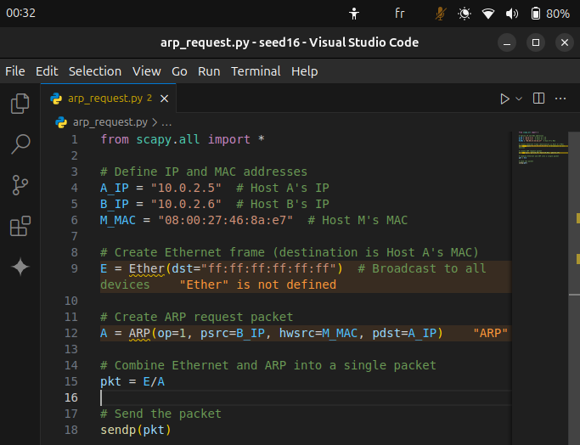
Code python for forging a packet arp request we’re saying to every body ‘hi who has ip A? I’m ip B) but in reality I’m ip X, but the problem is that the src mac address still is us he will make werong correspondance.
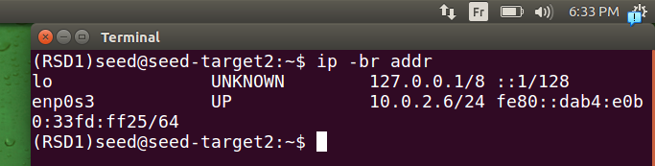
.this is the ip address of what we’re trying to pretend to be
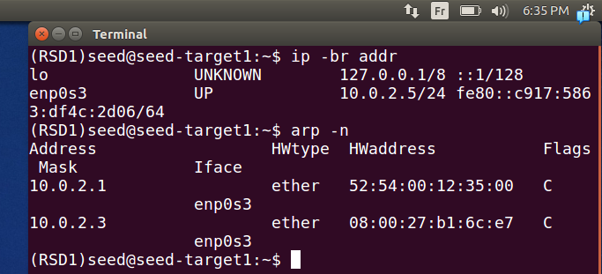
.here we see the address of the dst we want him to make us in his arp cache table, doesn’t exist the ip we want to pretend to be
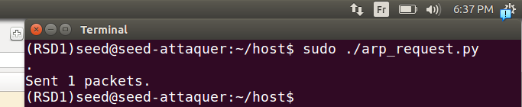
.here we sent a message (spoofing) from attaquer machine
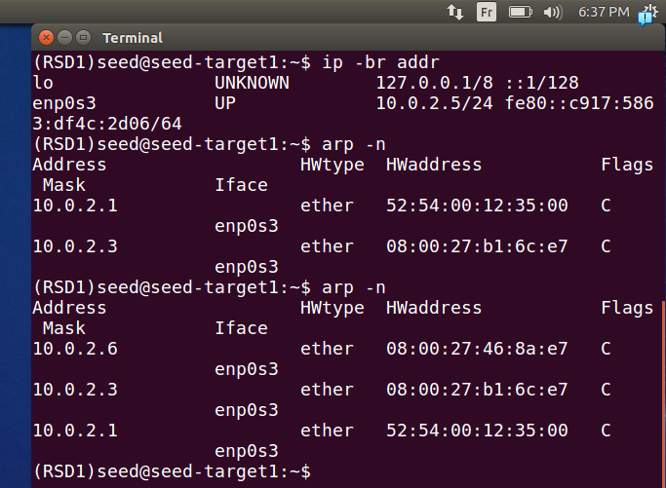
.we can see that the arp cache has bee updated
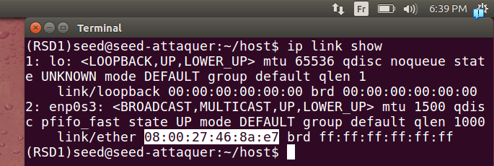
.with the mac address of attaquer machine
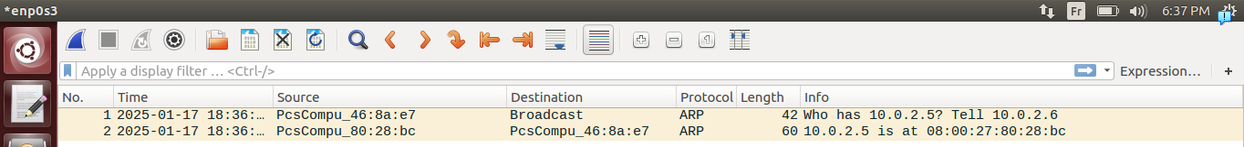
.we did a broadcast like you see, and we got a reply from machine with ip address dst.
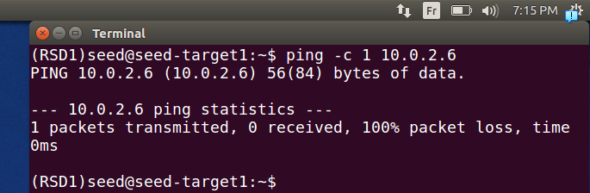
.here we try to ping from the machine that updated it’s table
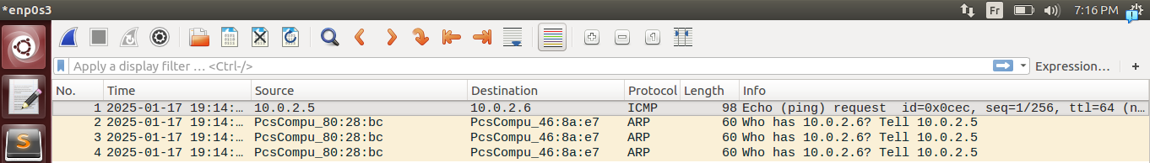
.we see an echo icmp message sent to ip address of target 2 bu with our mac our machine didn’t reply back so to us
.if we entre inside it we see the dest is to our mac address.(attaquer)
(***)note that after not getting a reply he’s starting to ask who has the ip address 10.0.2.6 but to destination of our mac address. Here if we while our machine target 1 will start asking everyone(broadcast) who has to update it’s ip row, note that between this two phases it names it incomplete.(***)

Opt2: in case already in arp cache table
We change it because we’re intersted in machine target 2
.here we changed in code the ip addresses
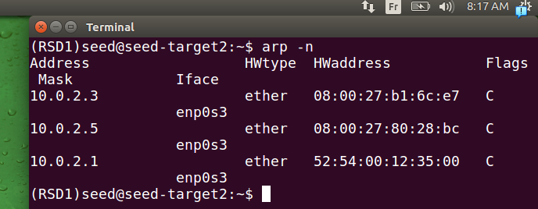
.we verify that ip address 10.0.2.6 is corresponding correctly to mac address (we will poison it)
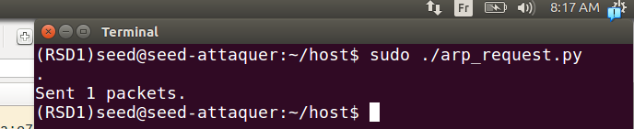
.we send the packet
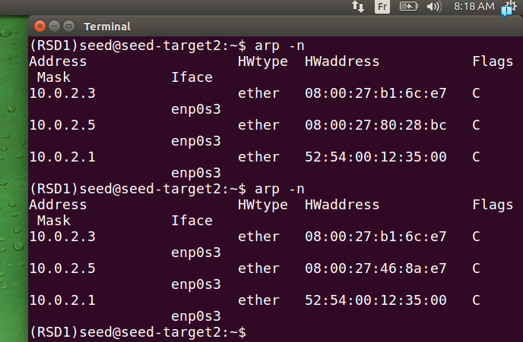
.the table is changed to our mac address of the attaquer
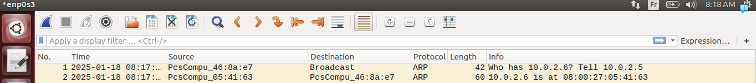
we can see that it worked correctly we got a response.
Note:
0- we could specifie directly it’s mac address if we already had it like this
E = Ether(dst = "08:00:27:80:28:bc")
it will not be a broadcast but directly to it. It’s better.
1-
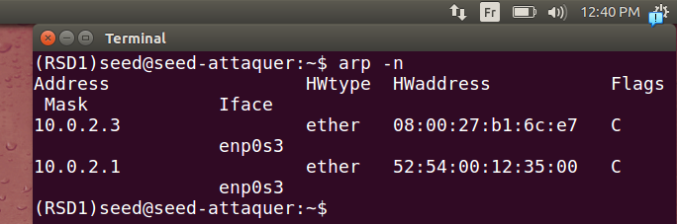
here there’s two ip addresses that are not machine’s addresses because one is gateway addresse and the other is DHCP server address we separate them for confilict perpose.
2-
to delete content in arp cache table:
sudo ip -s -s neigh flush all
3-
if we don’t specify Ether header:
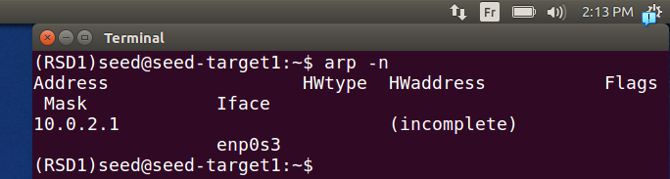
here the table of our target. (incomplete is because he didn’t resolve it yet because we flushed the arp cache table)
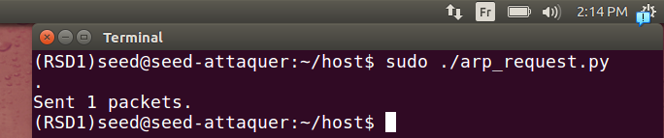
here we lunched our script with Ether()
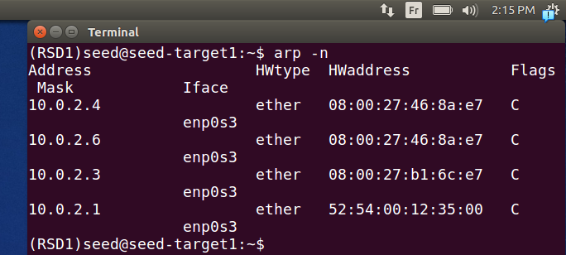
here he updated with two new ip with our mac in the two of them.
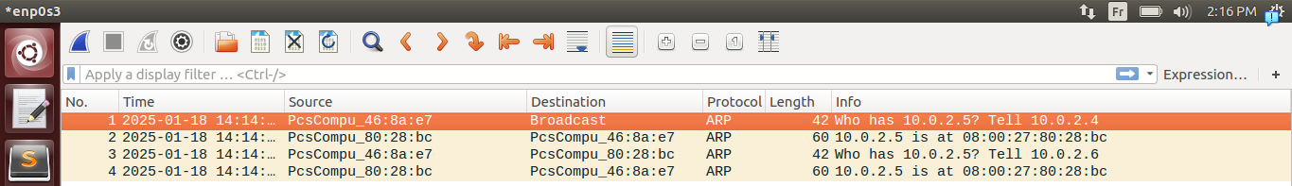
.this happened because like you see we send two times
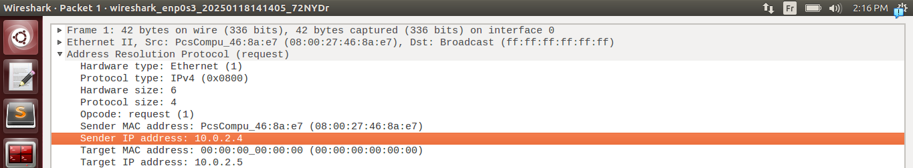
the first contains our mac and ip ip correctly because the os when we didn’t specify it he tried to make like reolving first the mac address of destination(scapy doesn’t take in account mac address if existant in arp cache already) this will make a good resolve for the victim
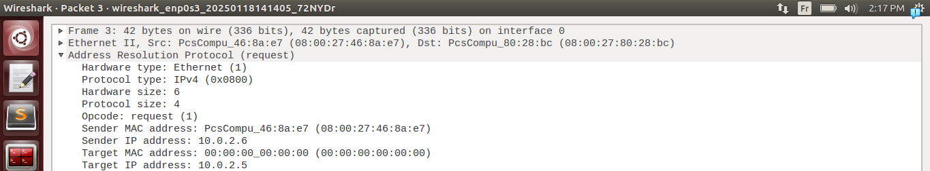
.here the spoffed one or what we wanted from the start he will make a bad resolve
4-
if we send without (p):
send(pkt)
and adding header:
E = Ether(dst ="08:00:27:80:28:bc")
we will get an error:
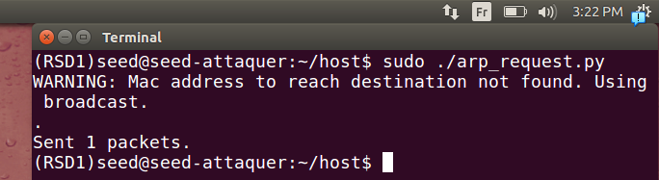
.here because when we put send without p it’s for layer 3, if scapy finds out it’s local address he will add an ethernet header himself 2 headers will make it malformed
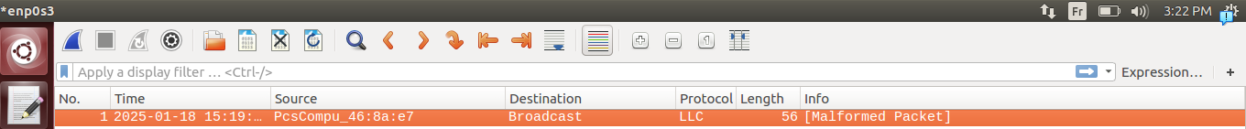
we got a malformed packet(note that LLC is for legacy network but it’s just because wireshark assumed that because malformed packet)
if we remove Ether header it will work fine .
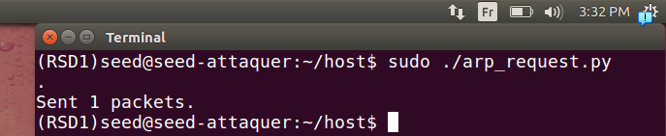
Here we send
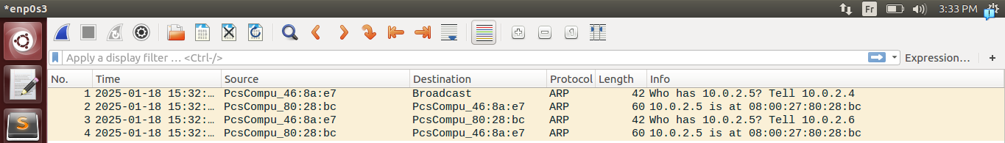
and it works correctly because it encapsulate it

Task 1B (using ARP reply).
Note that reply last time didn’t affect arp cache table because our machine discarded the packet even with mac correctly destinied for us because ip didn’t distinied to us so it didn’t work last time
But this time if we put it correctly to test what it do:
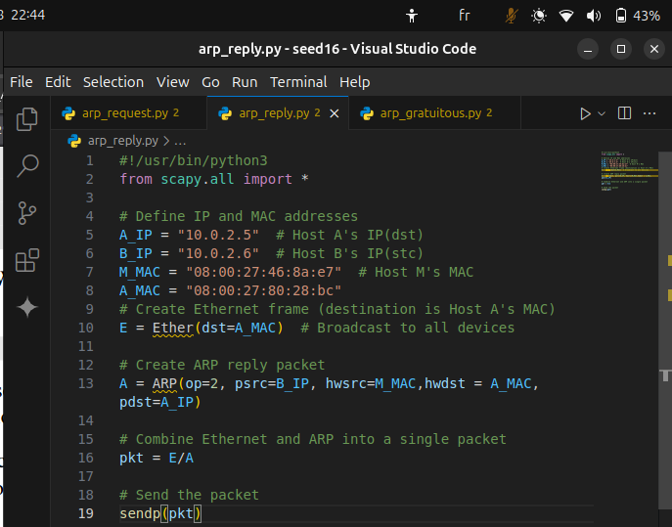
here we need to specify the destination mac address explicitly. Not like arp request last time.
If we use A_MAC = "ff:ff:ff:ff:ff:ff" it’s ok.but we need to specify dst
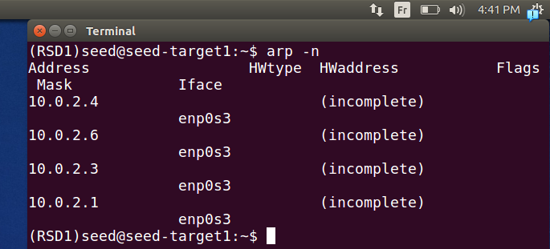
here nothing right now in arp cache of target because we flushed it .
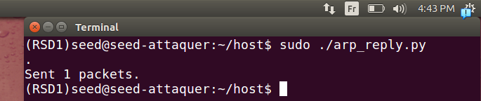
.here we send a reply to target 1
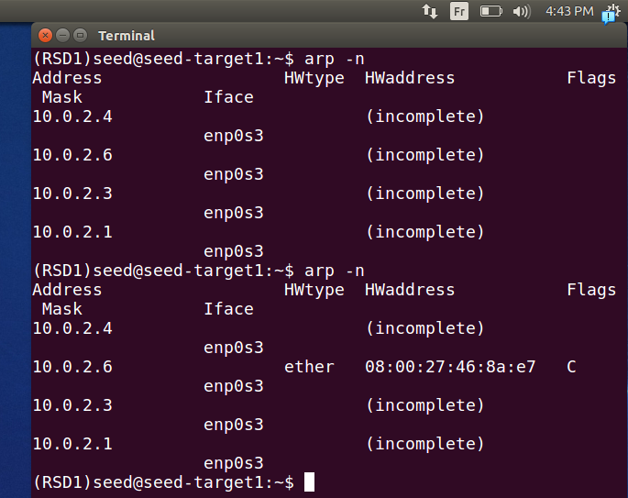
.here we can see that it updated
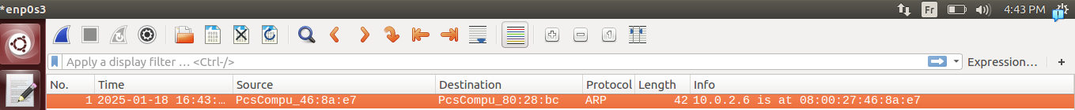
.we can see the meesage also in wireshark it’s working fine.
Note: that it be existing the as an entrie in victim machine the ip that we want to change it’s mac address
(the ip we want to change needs to be existing in the arp cache table, if it doesn’t it will not be changing)

Task 1C (using ARP gratuitous message).
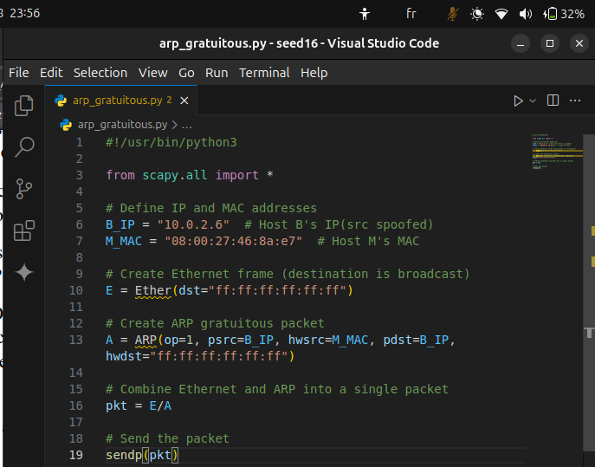
Here we put as description mentionned in
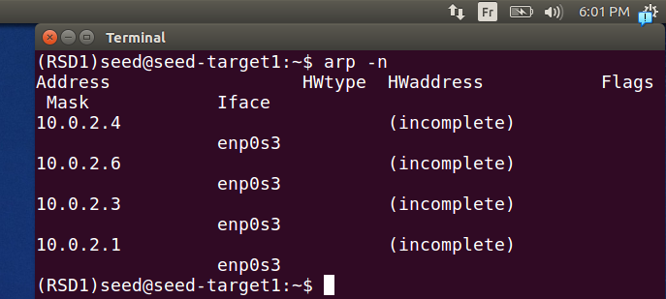
.here another time we flushed the arp cache
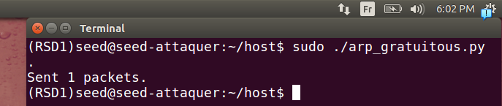
.here we lunch our script
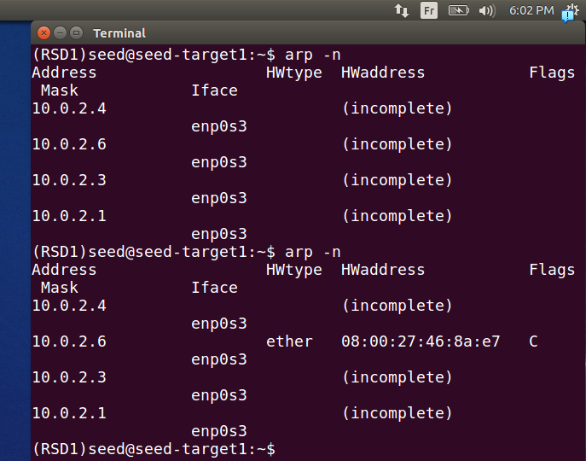
.we remarque that the arp cache table is updated
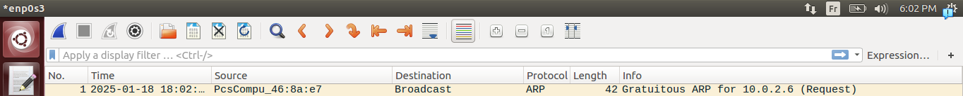
in wireshark it’s called gratuitous ARP for ipX , it works fine
Note
just to make sure it’s understood procedure of task1A (***), here if we do it to server DHCP 10.0.2.3:
B_IP = "10.0.2.3" # Host B's IP(src spoofed)

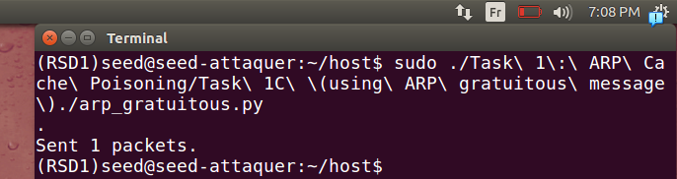
here we send a packet
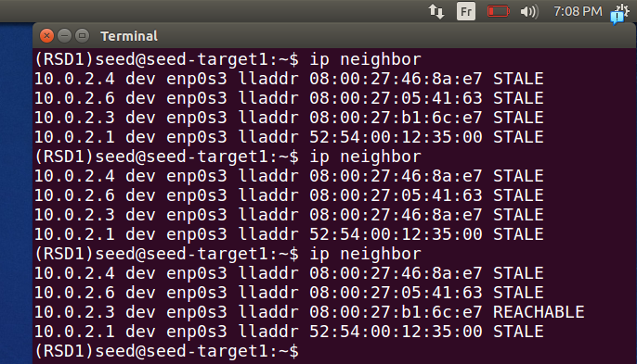
.the first is done before sending packet from attaquer
second is after directly
and the third is after some time
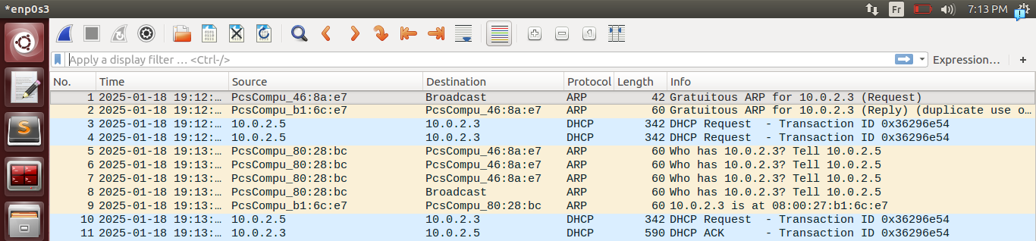
.here we remaruqe as mentionned previously
States in ARP Cache:
REACHABLE: The MAC address is valid and actively used recently.
STALE: The MAC address is known but hasn’t been used in a while. If needed, ARP will verify it again.
FAILED: ARP could not resolve the IP to a MAC address (e.g., target device is offline or unreachable).

Task 2: MITM Attack on Telnet using ARP Cache Poisoning

Step 1 (Launch the ARP cache poisoning attack).
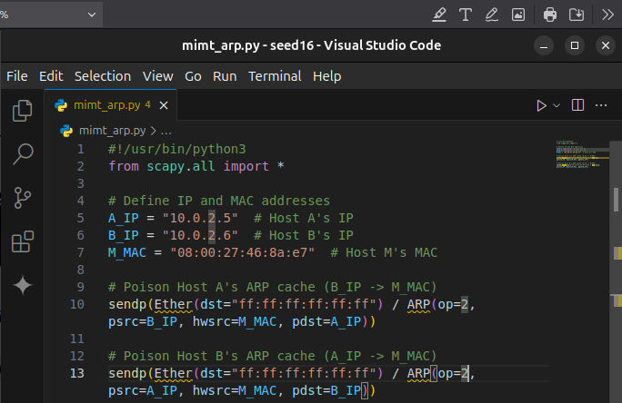
.we don’t really neeed to know their mac addresses to perform it so we broadcast two times to everybody for changing one to target 1 I’m with ip of target 2 and my mac address is of attaquer, and same for target 2 (inverse)
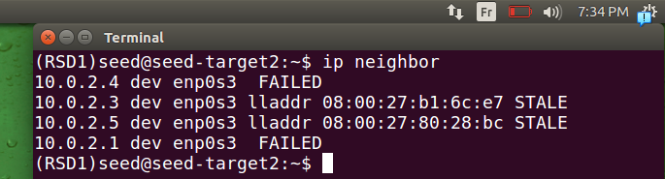
.we show what was it before target2
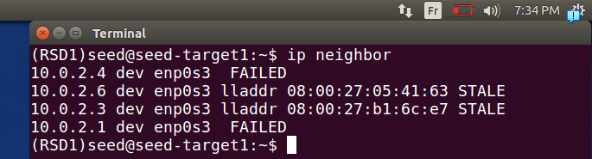
..we show what was it before target1
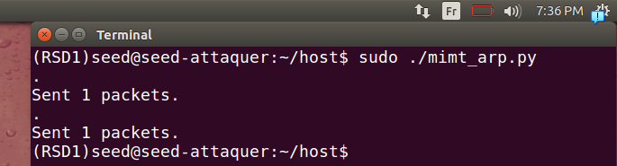
.we lunch script
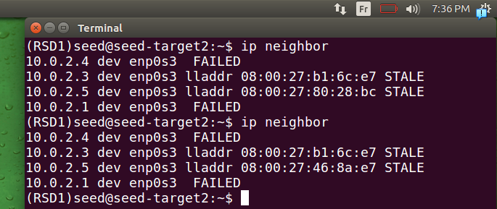
.it seem that it changed for target 2
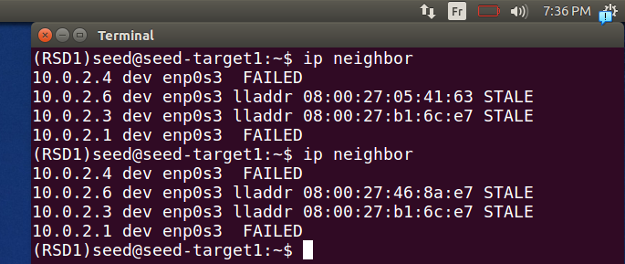
.same goes for target 1
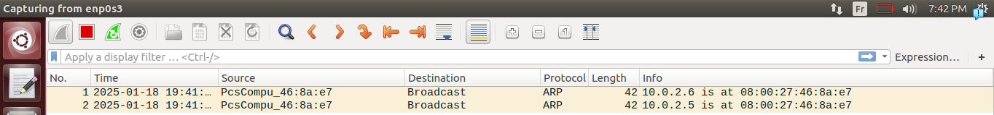
and we can see it in wireshark

Step 2 (Testing).
For taget1
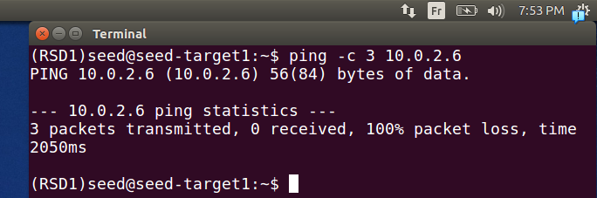
For machine target1 we ping target2
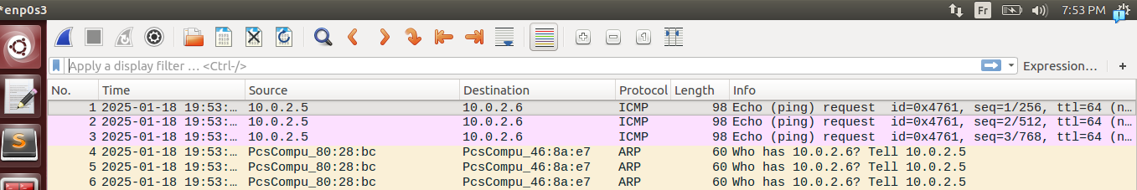
we can see trying requests without responses wich leads to asking our attaquer machine if it has the ip address target2 we don’t respond it will lead to broadcast asking about it .
Same goes for target2
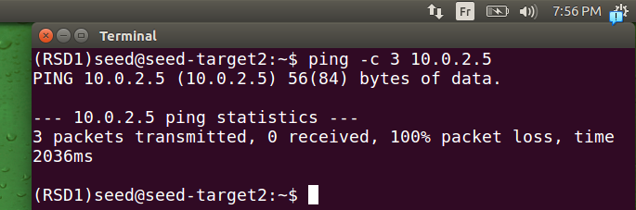
.
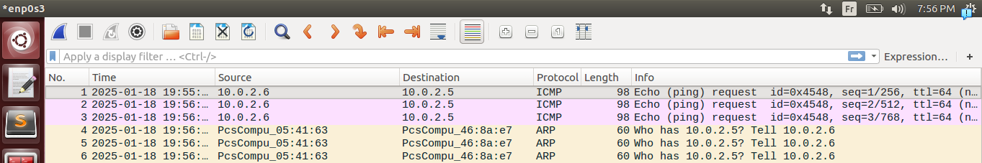
.

Step 3 (Turn on IP forwarding).
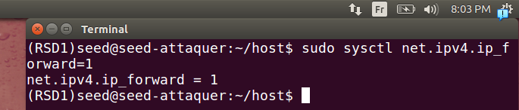
We turn it on using commnd given
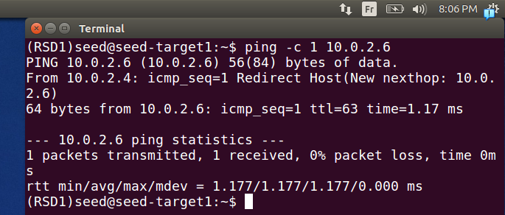
we ping traget 2 one time .(but note that redirect Host is for ICMP Redirect explained later)
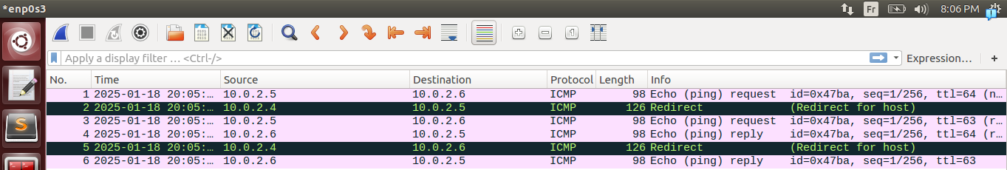
We can how our packet is working fine
target1→attaquer(ICMP Request)
attacker→target1(ICMP Redirect)
attaker→ target2(ICMP request)
target2→attaquer(ICMP Reply)
attacker→target2(ICMP Redirect)
attaker→ target1(ICMP Reply)
ICMP Redirect is a message sent by a router to inform a host that there is a better route for a specific destination.

Step 4 (Launch the MITM attack).
First we make a code to update each time like step 1 but each 10sec:
.

opt1:
.
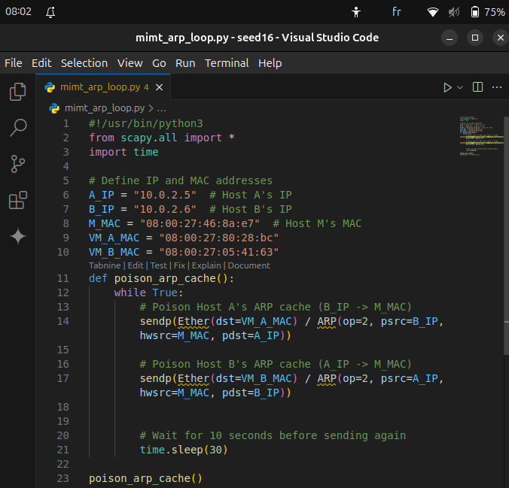
here same code of step one, but to not update it each time for purpose testing and keeping his arp table in shape we make it as a loop
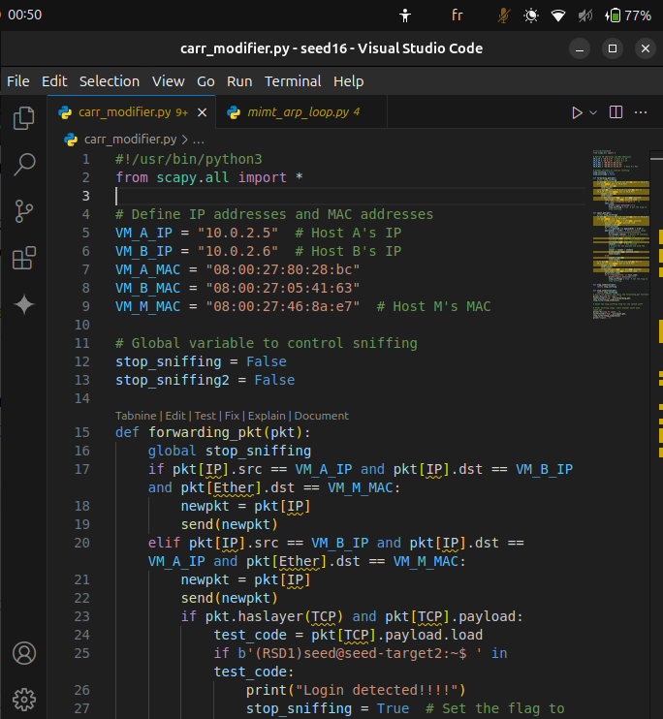
Here in first we did programme we made some improvement we decided to not make it manualy the logic of starting the forwarding then stoping it afterward because we don’t know when the victim will login like to simulate reality more because telnet the reply of dst will be the afficahge we decided to if we got ‘xxxxxxxxxxtarget2’ means he’s loged in so we start modifying his input to be like they wanted “Z”
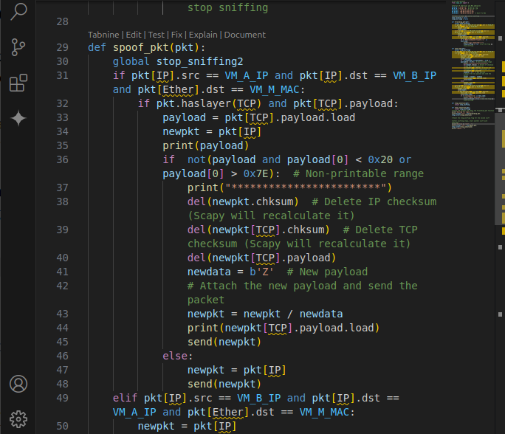
.the seconde function lunched after if it’s printible we just change it to ‘Z’ like he want
.
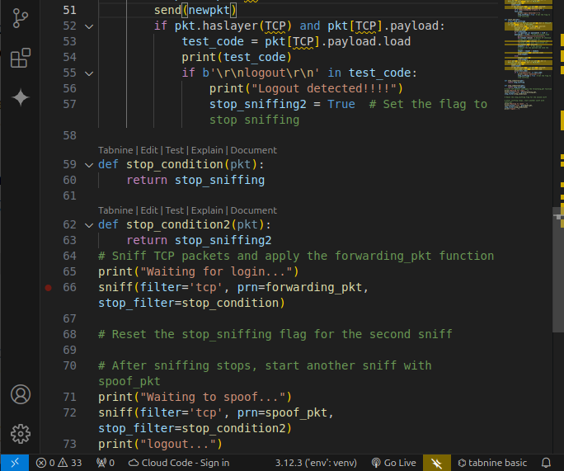
.when he logout we stop the capturing here we should’ve returned to first version of forwading.
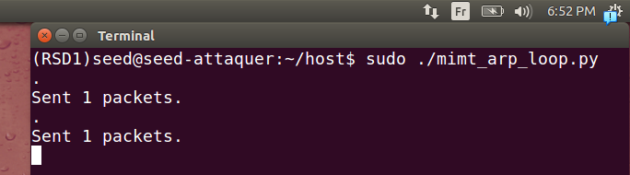
.here we lunched our script of updating the arp table .
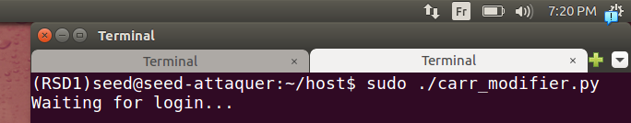
.here we lunched the script of forwarding and modifying packets
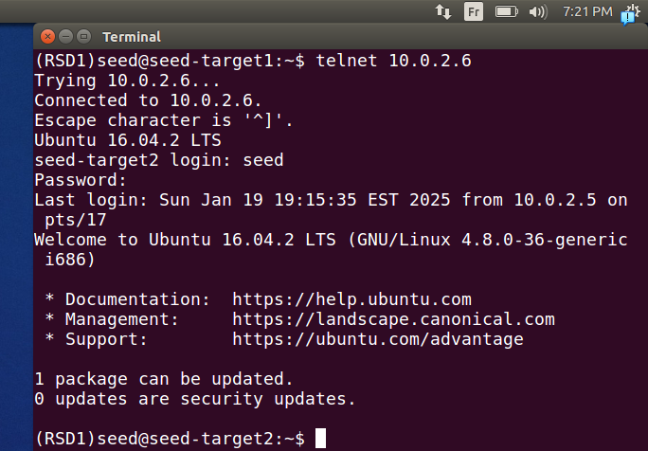
.here we login to target2 it should appear that we logged in succeffully
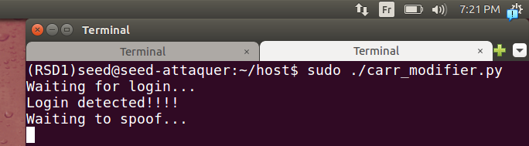
here it worked correctly and we’re starting to change packets when he write
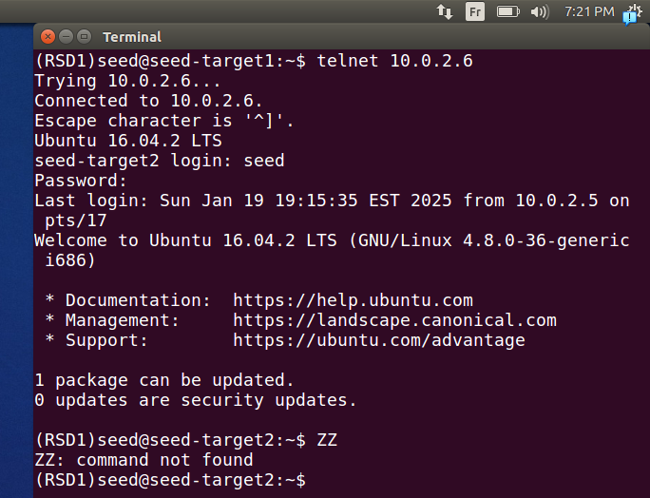
.here when he write it’s chnged to ‘Z’ as wanted
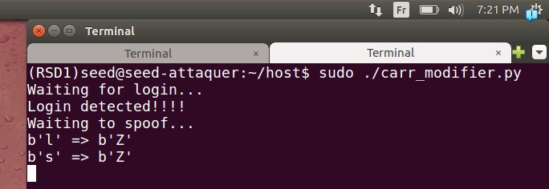
.here we it shows that it changed correctly

opt2:
In option 2 we improved so he doesn’t detect that we’re changing his carracterres
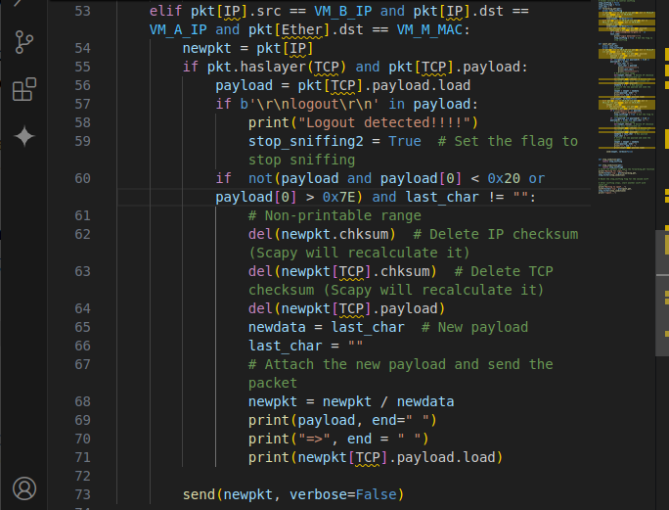
.here we’re saving the last carracterre, so we will give him back with the dst when reply because as we said before in telnet the response is what’s giving to us by him so we show it in terminal .
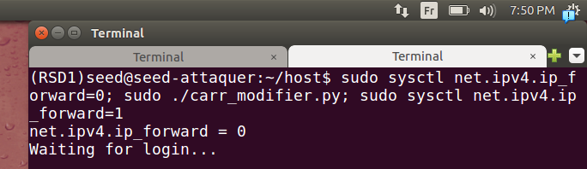
.here we make forwading 0 to ensure it doesn’t confuse with our forwarding programme
(we don’t want to have 2 forwarding at same time ok), we lunch our programme, after finding the carracterre we will stop stop; then to ensure that he keeps working ok we will return it to forwarding = 1
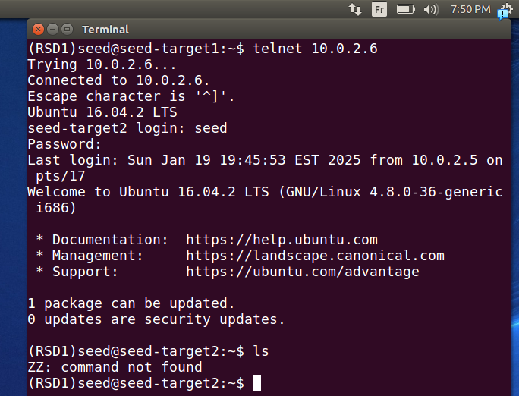
.here we lunched and we see it seems that he’s writing ‘ls’ but in reality he’s sending ‘ZZ’
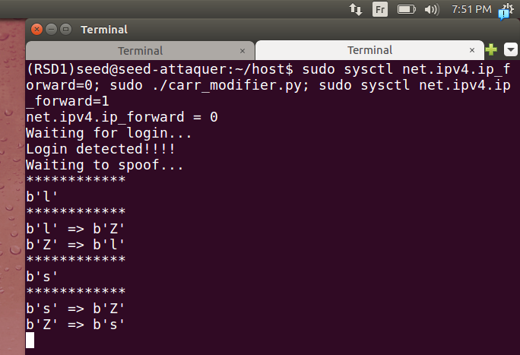
.we can see it clearly here!

Opt3:
In option 3 we iserted a new variable it will our command that we intent to spoof so he think that he’s typing but in reality it’s command writing by us .
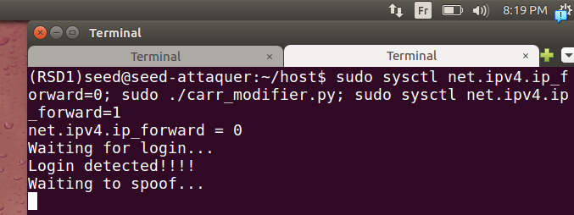
.
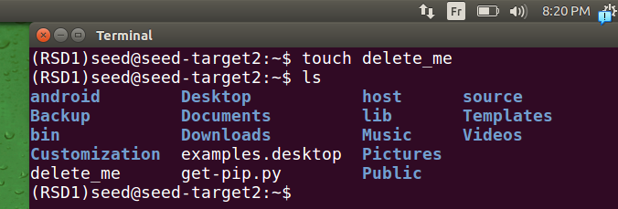
.here we create in machine target 2 or telnet server as intended a file delete_me it’s what we want to delete (as prove that it works fine)
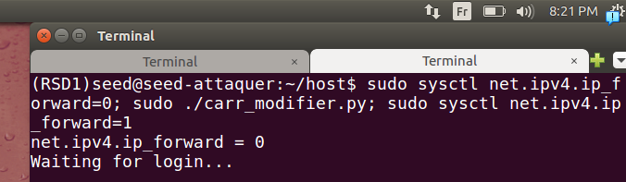
.here we lunch our script as mentionned in option 2 last time

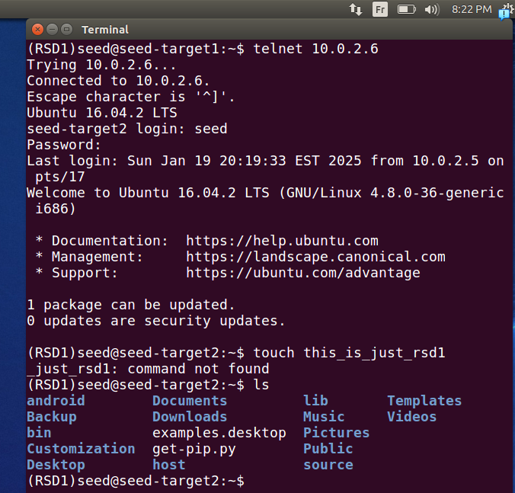
.here we login then we write a command . commande = "rm delete_me;" Here we put ‘;’ this to not affecte his command .
Note: that our programme still can be imporoved and take in account the length of our comman

Task 3: MITM Attack on Netcat using ARP Cache Poisoning
Here we show how netcat works in real
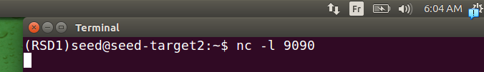
.he we lunch a listenning in port 9090 tcp par default
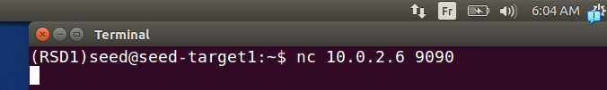
.we try to connect to target2 via port specified last time
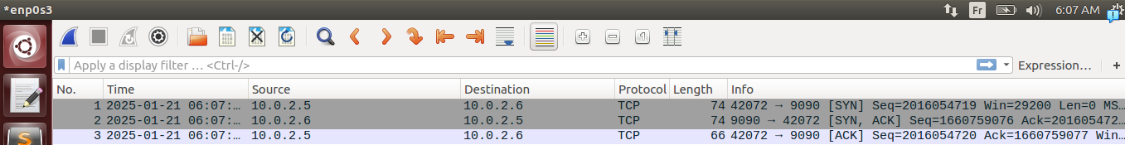
.we can that first there’s three way hanshake (seq, seq ack, ack)
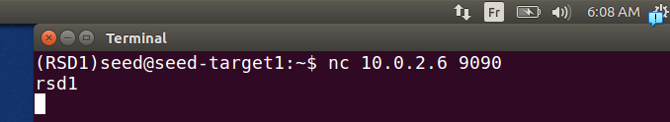
.if we write some carracterre it appears in the other face
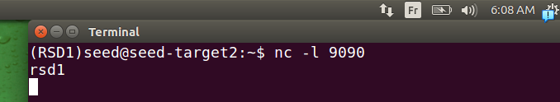
.here we can see that we gote it correctly
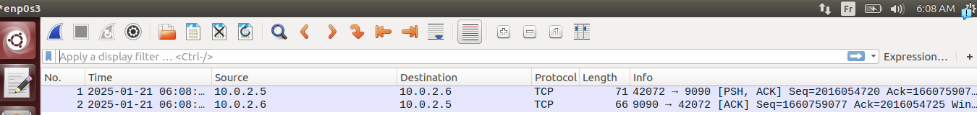
.there’s always an ack to each write, we press entre to send it (fiability)
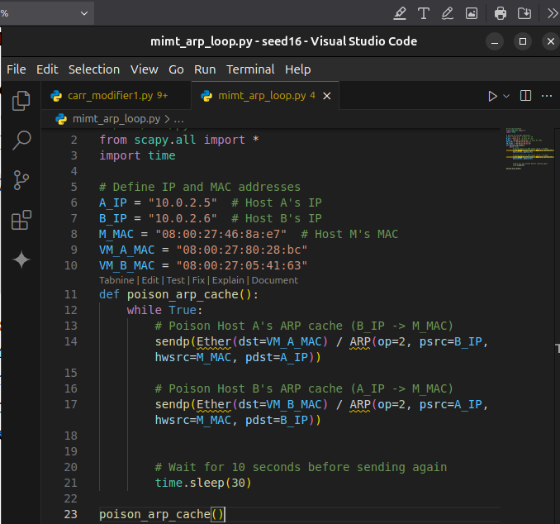
.
.here we will use the code of last time, to make it update each time the arp table so we don’t lose time.
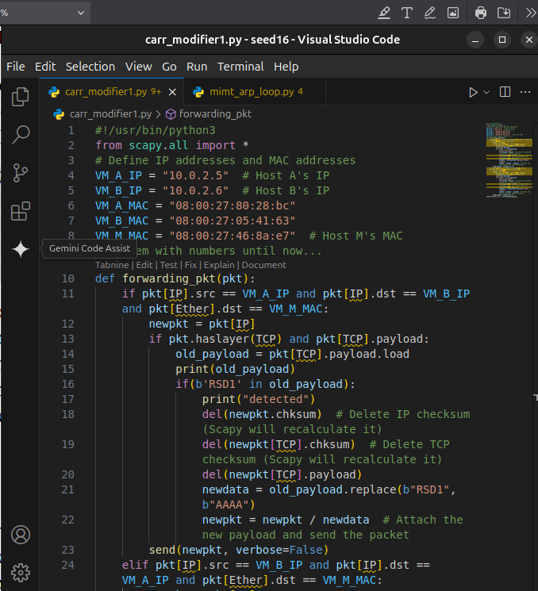
.we modify the code of last time it’s a code that forward everything, how it works it just
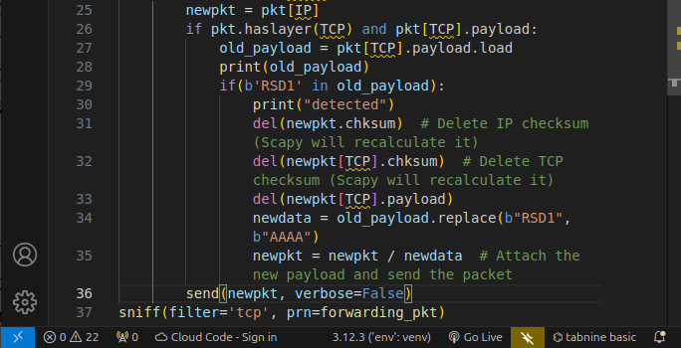
.same for packets coming from B to A
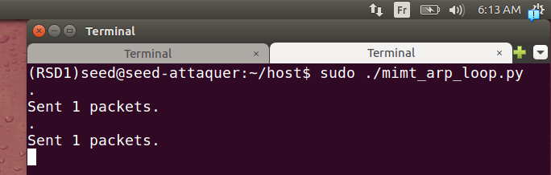
.we lunch code that updates arp cache table
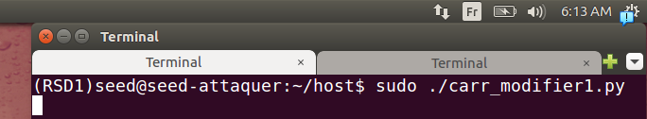
.we lunch our script that forward and modify
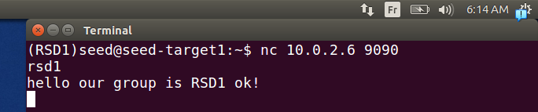
.we send some phrases from A->B
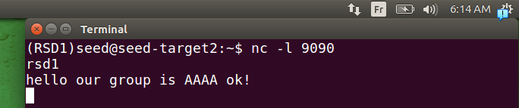
.we can see result in in B if we A→B request our code is working fine
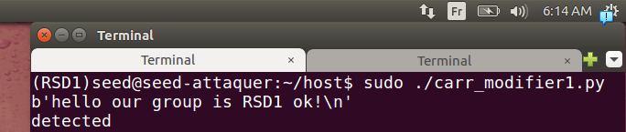
.yes it’s shown in our script what they send MITM
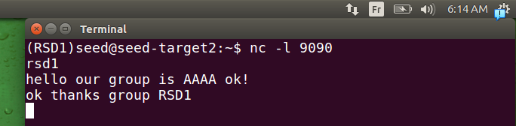
.for testing purpose we can see that it works backward also
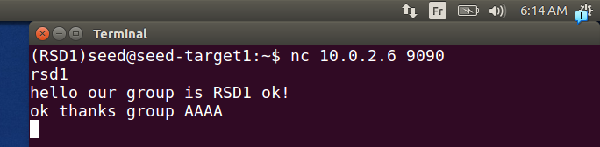
result correctly seen
.
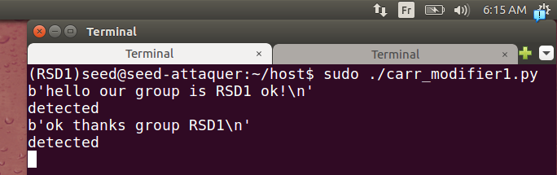
.and good show in script.

